**THE SYMPHONY OF PNEUMONIA DETECTION USING**

**DEEP LEARNING**

$MENTOR-{Ms M B AHMED SAMATHANI}^{1}$,

${ASHISH A V}^{1}$, ${GANESH M D}^{2}, {HARISH KUMAAR}^{3}, {BOGESH P}^{4}$

MENTOR – ASSISTANT PROFESSOR, SRM VALLIAMMAI ENGINEERING COLLEGE

STUDENTS – SRM VALLIAMMAI ENGINEERING COLLEGE

**ABSTRACT**

Pneumonia, a potentially fatal lung infection typically caused by Streptococcus pneumoniae, is traditionally diagnosed through manual interpretation of chest X-rays by expert radiologists, which can be costly and time-consuming. An alternative approach involves leveraging automated systems to identify pneumonia from chest X-ray images, offering a more economical and accessible solution. The dataset obtained from Kaggle serves as a valuable resource for developing and testing automated pneumonia identification systems. Using pre-trained Convolutional Neural Network (CNN) models, these systems analyze image features and patterns, enabling efficient pneumonia detection without the need for specialized expertise. This automated approach facilitates early detection of pneumonia, allowing for prompt initiation of treatment during the early stages of the disease. By reducing reliance on expert radiologists, this method not only increases accessibility to diagnosis but also aids physicians in confirming pneumonia diagnoses swiftly and accurately. Early detection is critical in enabling timely medical interventions, which can significantly improve patient outcomes by preventing disease progression and complications. By streamlining the diagnostic process and empowering healthcare providers with automated tools, this approach contributes to more effective management of pneumonia cases, ultimately leading to better patient care and outcomes.

**INTRODUCTION**

This study tackles childhood pneumonia, a major cause of mortality, by proposing CNN models for precise chest X-ray classification. It sidesteps transfer learning due to dataset constraints and creates four CNN models. Emphasis is placed on achieving high recall, accuracy, and F1 scores to minimize false negatives and ensure patient safety. Methodology details model architecture and dataset utilization, while results feature accuracy and loss graphs alongside confusion matrices for performance evaluation. The paper concludes by selecting the most effective model and outlining future research avenues. By prioritizing recall and patient safety, this research contributes to bolstering the reliability and efficacy of medical imaging in combatting childhood pneumonia, thereby potentially reducing mortality rates and improving healthcare outcomes for affected children.

Advancements in deep learning, particularly Convolutional Neural Networks (CNNs), have shown significant promise in pneumonia detection from chest X-ray images, critical for ensuring timely and accurate diagnosis, especially in vulnerable populations like children and the elderly. CNNs, renowned for their ability to process visual data, leverage vast datasets of labeled chest X-rays to discern intricate patterns and features indicative of pneumonia, facilitating automated detection. The process encompasses several crucial stages: data acquisition involves gathering diverse chest X-ray images from multiple medical sources to ensure representation across demographics and pneumonia manifestations; preprocessing aims to enhance image quality through resizing, normalization, and noise reduction, thereby optimizing CNN performance; model training entails training CNN architectures to differentiate between normal and pneumonia-affected lungs by learning disease-specific features.

Following model training, validation and evaluation are conducted to test the trained models against separate datasets and expert annotations, ensuring their clinical relevance and reliability. Once validated, CNN models are deployed in clinical settings to aid radiologists in pneumonia diagnosis, expediting patient management and treatment decisions. CNN-based pneumonia detection offers several advantages, including enhanced accuracy due to the capability to learn complex patterns, improved time efficiency through automated analysis, and increased accessibility in diverse healthcare settings. Through the integration of CNN-based deep learning techniques, medical imaging stands to make significant strides in enhancing diagnostic capabilities, ultimately advancing patient care and outcomes.

**RELATED WORKS**

**EXISTING SYSTEM:**

In recent years, significant strides have been made in image classification, particularly within the realm of medical imaging. Researchers have leveraged convolutional neural network (CNN) models to accurately classify chest X-ray images and identify abnormalities associated with thorax diseases and pulmonary tuberculosis. For instance, Rubin et al. employed a DualNet CNN model on the MIMIC-CXR dataset, achieving notable average AUC scores for different views. Similarly, Lakhani et al. utilized transfer learning with models like AlexNet and GoogleNet, achieving an impressive AUC of 0.99 for pulmonary tuberculosis classification. These advancements highlight the efficacy of CNN-based approaches in enhancing diagnostic capabilities for respiratory conditions.

Moreover, CNN architectures developed by Krizhevsky et al. and Simonyan et al. have significantly improved image classification accuracy, further augmenting diagnostic capabilities in medical imaging. Beyond chest X-rays, CNN models have been extended to various medical imaging domains, such as brain tumor segmentation by Xu et al. and interstitial lung disease detection by Anthimopoulos et al. These efforts underscore the versatility of CNNs in addressing diverse medical imaging challenges, ultimately leading to more accurate diagnoses and improved patient care.

Furthermore, innovations in neural network architectures, such as residual neural networks (RNNs) introduced by He et al., have addressed critical issues like vanishing gradients, contributing to state-of-the-art performance in image classification tasks. Additionally, transfer learning models and novel neural network architectures, such as the extension of AlexNet by Glozman et al. and the neural network models MCPN and MKNN by Hemanth et al., have further propelled the field forward, showcasing high accuracies and mitigating convergence time challenges. Collectively, these advancements underscore the significant progress made in accurately classifying medical images, heralding a new era of enhanced diagnostic capabilities and patient outcomes.

**LITERATURE SURVEY**

**AUTHOR:** T. RAHMAN, E.H. MUHAMMAD

# TITLE: TRANSFER LEARNING WITH DEEP CONVOLUTIONAL NEURAL NETWORK (CNN) FOR PNEUMONIA DETECTION USING CHEST X-RAY

**DESCRIPTION**: Used digital x-ray images to detect the bacterial and viral pneumonia. Four different pre-trained deep Convolutional Neural Networks (CNN): Alex Net, ResNet18, DenseNet201, and Squeeze Net were used for transfer learning. This proposed study can be useful in quickly diagnosing pneumonia by the radiologist .

**AUTHOR:** ALHAZMI LAMIA 1 AND ALASSERY FAWAZ

**TITLE:** DETECTION OF PNEUMONIA INFECTION BY USING DEEP LEARNING ON A MOBILE PLATFORM

**DESCRIPTION:** Developing a mobile app utilizing deep learning for pneumonia diagnosis addresses the challenge of limited experts and diagnostic tools. The research focuses on creating a user-friendly prototype using Create ML, eliminating complexities in neural network configuration. With over 5,000 real images, the image classification model ensures accessible pneumonia detection via a mobile application. The simplified process eliminates concerns about network layers, parameter initialization, and algorithm choices. Create ML's graphical interface makes training the model easy without requiring specialized knowledge Are Identified in This Research.

**AUTHOR:** EL. KHALID , ASNAOUI

**TITLE:** AUTOMATED METHODS FOR DETECTION AND CLASSIFICATION PNEUMONIA BASED ON X-RAY IMAGES USING DEEP LEARNING

**DESCRIPTION:** Different types of single and ensemble learning models were utilized to classify pneumonia. Ensemble learning involves combining multiple models into a single model to tackle a specific task, with the choice of models being determined by the requirements and characteristics of the problem at hand. Currently, ensemble models are commonly employed for making predictions, including classification and regression tasks. By training a single model independently within an ensemble, improved accuracy can be achieved. In particular, an ensemble of three models demonstrated higher accuracy in this study.

**AUTHOR:** SHIMPY GOYAL, RAJIV SINGH

**TITLE:** DETECTION AND CLASSIFCATION OF LUNG DISEASES FOR PNEUMONIA AND COVID‑19 USING MACHINE AND DEEP LEARNING TECHNIQUES

**DESCRIPTION:** In response to the novel Covid-19, research efforts have surged worldwide to accurately predict the disease. This paper proposes a framework using chest X-ray images for predicting lung diseases, including pneumonia and Covid-19. The innovative approach involves dataset acquisition, image quality enhancement, precise region of interest estimation, and disease anticipation, demonstrating robustness and efficiency compared to existing methods Are Examined In This Research

**AUTHOR:** WASIF KHAN, NAZAR ZAKI

**TITLE:** INTELLIGENT PNEUMONIA IDENTIFICATION FROM CHEST X-RAYS: A SYSTEMATIC LITERATURE REVIEW

**DESCRIPTION:** This helps practitioners to select the most effective and efficient methods from a real-time perspective, review the available datasets, and understand the results obtained in this domain. The usability, goodness aspects, and computational complexity of the algorithms used for intelligent pneumonia identification are examined in this research.

0020

**AUTHOR:** PATRIK SZEPESI, LA´SZLO´SZILA´GYI,

**TITLE:** DETECTION OF PNEUMONIA USING CONVOLUTIONAL NEURAL NETWORKS AND DEEP LEARNING

**DESCRIPTION:** The objective and automated detection of pneumonia represents a serious challenge in medical imaging, because the signs of the illness are not obvious in CT or X-ray scans. Further on, it is also an important task, since millions of people die of pneumonia every year. The main goal of this paper is to propose a solution for the above mentioned problem, using a novel deep neural network architecture. The proposed novelty consists in the use of dropout in the convolutional part of the network. The proposed method was trained and tested on a set of 5856 labeled images available at one of Kaggle’s many medical imaging challenges. The chest X-ray images (anterior-posterior) were selected from retrospective cohorts of pediatric patients, aged between one and five years, from Guangzhou Women and Children’s Medical Center, Guangzhou, China. Results achieved by our network would have placed first in the Kaggle competition with the following metrics: 97.2% accuracy, 97.3% recall, 97.4% precision and AUC ¼ 0:982, and they are competitive with current state-of-the-art solutions

**PROPOSED SYSTEM**

**Enhancing Diagnostic Precision with CT Imaging:**

The project aims to develop and implement a deep learning model tailored for pneumonia detection using computed tomography (CT) imaging. This aligns with the World Health Organization's recommendation to enhance diagnostic accuracy. CT scans offer superior capabilities compared to chest X-rays, providing detailed and comprehensive information essential for pneumonia diagnosis. By leveraging CT imaging, the project seeks to address the limitations of chest X-ray imaging, characterized by inter-class variability. The goal is to improve diagnostic precision and accuracy, leading to more effective treatment and management of pneumonia cases.

**Mitigating Diagnosticians Shortage through Automation:**

The project will focus on developing an automated pneumonia detection system using deep learning models to address the critical shortage of diagnosticians. By utilizing advanced architectures like Generative Adversarial Networks (GANs), the system aims to enhance the efficiency of pneumonia detection from chest X-ray images. This will reduce reliance on expert radiologists and improve the accessibility of diagnostic services, particularly in areas with limited healthcare resources. The automation of pneumonia detection will streamline the diagnostic process, enabling timely interventions and improving patient outcomes.

**Standardizing and Objectifying Pneumonia Diagnosis:**

The proposed deep learning model will undergo comprehensive validation studies to ensure consistent and reliable performance across diverse patient populations and medical settings. By addressing the subjective variability associated with X-ray examinations, the project aims to provide a standardized and objective approach to pneumonia diagnosis. This will contribute to more consistent and accurate results, reducing the risk of misdiagnosis and improving patient care. Emphasis will be placed on the potential of deep learning models, such as GANs, to significantly enhance the accuracy of pneumonia diagnosis, leading to a more reliable and automated diagnostic process.

Top of Form

**ARCHITECTURE DIAGRAM**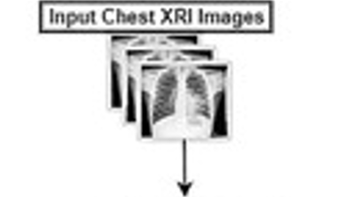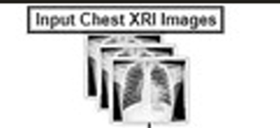

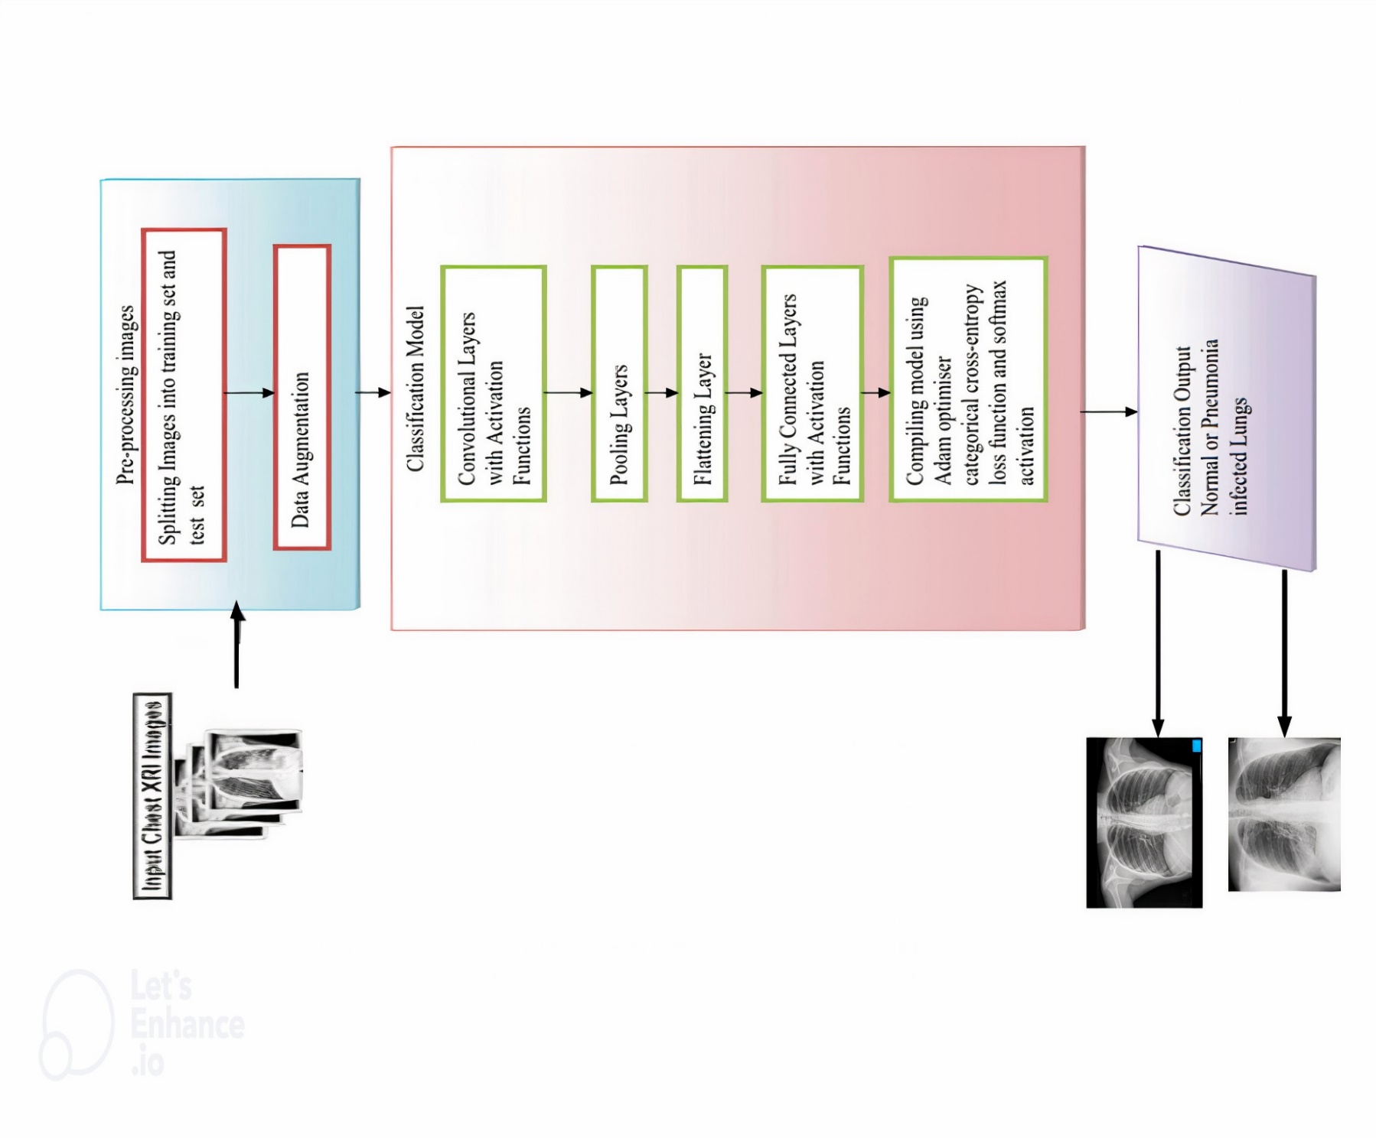

Top of Form

**IMPLEMENTATION:**

**MODULE I - DATA DESCRIPTION**

* A comprehensive dataset for pneumonia detection using CNNs should include a diverse collection of chest X-ray images, each accompanied by accurate labels indicating the presence or absence of pneumonia. These images should cover a wide range of conditions, including normal lung images and various types and severities of pneumonia. Data augmentation techniques can be applied to enrich the dataset and improve model generalization. The dataset should be divided into training, validation, and test sets to facilitate model training, hyperparameter tuning, and evaluation. It's essential to ensure the quality and accuracy of the data, preferably with radiologist-verified labels, while also adhering to ethical considerations regarding patient privacy and confidentiality.
* Data quality is paramount, ideally verified by radiologists to ensure label accuracy and image integrity. Ethical considerations, including patient privacy and confidentiality, must be upheld throughout dataset acquisition and usage. In summary, a well-curated dataset, spanning a breadth of conditions and verified for accuracy, forms the foundation for training reliable CNN models for pneumonia detection, ultimately contributing to improved diagnostic accuracy in clinical settings.

Top of Form

**MODULE II – DATA PREPROCESSING**

Data preprocessing plays a crucial role in preparing chest X-ray images for pneumonia detection using CNNs.

Here's an overview of the preprocessing steps:

1. **IMAGE RESIZING:** Resize the chest X-ray images to a consistent size, typically square dimensions. This ensures uniformity in input size, which is essential for CNNs to process images efficiently.

2. **NORMALIZATION:** Normalize pixel values to a common scale, typically between 0 and 1 or -1 and 1. Normalization helps stabilize training by ensuring that features are on a similar scale, preventing certain features from dominating others during the optimization process.

3. **NOISE REDUCTION:** Apply noise reduction techniques to enhance image quality and reduce irrelevant details that could hinder the CNN's ability to learn meaningful features. Common noise reduction methods include Gaussian blurring or denoising filters.

4. **CONTRAST ENHANCEMENT:** Enhance image contrast to highlight relevant features and improve the CNN's ability to detect subtle patterns associated with pneumonia. Techniques such as histogram equalization or adaptive histogram equalization can be employed for contrast enhancement.

5. **DATA AUGMENTATION:** Augment the dataset through techniques such as rotation, translation, flipping, and scaling. Data augmentation helps increase the diversity of the training data, improving the model's ability to generalize to unseen variations in input images.

6. **LABEL ENCODING:** Encode categorical labels (e.g., normal, pneumonia-positive) into numerical format suitable for model training. For binary classification tasks, this may involve assigning numerical values (e.g., 0 for normal, 1 for pneumonia-positive).

7. **DATA SPLITTING:** Divide the pre-processed dataset into training, validation, and test sets. The training set is used to train the CNN model, the validation set is used for hyperparameter tuning and model evaluation during training, and the test set is reserved for final evaluation of the trained model's performance on unseen data.

**MODULE III: CONVOLUTIONAL NEURAL NETWORK (CNN) ARCHITECTURE**

A Convolutional Neural Network (CNN) architecture for pneumonia detection typically consists of multiple layers designed to extract features from chest X-ray images and classify them as normal or pneumonia-positive.

Here's a basic outline of a CNN architecture suitable for this task:

1. **INPUT LAYER:** The input layer receives the chest X-ray images as input. The size of the input layer corresponds to the dimensions of the input images, typically in the form of height, width, and number of channels (e.g., grayscale or RGB).

2. **CONVOLUTIONAL LAYERS:** Convolutional layers apply convolutional filters to the input images to extract features such as edges, textures, and shapes. Each convolutional layer consists of multiple filters or kernels, each producing a feature map by convolving over the input image. Convolutional layers are often followed by activation functions such as ReLU (Rectified Linear Unit) to introduce non-linearity into the model.

3. **POOLING LAYERS:** Pooling layers downsample the feature maps generated by the convolutional layers, reducing their spatial dimensions while retaining important features. Common pooling operations include max pooling or average pooling, which extract the maximum or average value within a local region of the feature map, respectively.

4**. ADDITIONAL CONVOLUTIONAL AND POOLING LAYERS:** Multiple convolutional and pooling layers are typically stacked to create deeper representations of the input images, capturing increasingly abstract features relevant to pneumonia detection.

5. **FLATTENING LAYER:** The flattening layer transforms the multi-dimensional feature maps into a one-dimensional vector, preparing them for input into the fully connected layers.

6**. FULLY CONNECTED LAYERS:** Fully connected layers process the flattened feature vectors and perform classification tasks. These layers consist of densely connected neurons, with each neuron connected to every neuron in the preceding layer. Activation functions such as ReLU are commonly used in fully connected layers as well.

7.**OUTPUT LAYER:** The output layer produces the final predictions, indicating whether the input image is normal or pneumonia-positive. In binary classification tasks like pneumonia detection, a single neuron with a sigmoid activation function is often used to output the probability of pneumonia presence.

**MODULE IV: TRAINING AND OPTIMIZATION**

1. **LOSS FUNCTION:** Choose a suitable loss function for binary classification, such as binary cross-entropy, which measures the difference between predicted probabilities and actual labels. It penalizes misclassifications by assigning higher loss to incorrect predictions, guiding the model towards better classification performance.

2. **OPTIMIZER:** Select an optimizer to update the model's weights during training. Common choices include Adam, which adapts the learning rate for each parameter based on past gradients, and SGD (Stochastic Gradient Descent), which updates weights based on the gradient of the loss function with respect to the parameters. Consider factors like convergence speed and stability when choosing an optimizer.

3. **LEARNING RATE:** Fine-tune the learning rate, a crucial hyperparameter that controls the size of weight updates during training. Optimal learning rates vary depending on the dataset and model architecture. Experiment with different learning rates and monitor the model's performance on the validation set to find the best value that ensures convergence without oscillation or divergence.

4**. TRAINING:** Train the model on the training dataset using the chosen loss function, optimizer, and learning rate. Monitor training progress by tracking metrics like loss and accuracy. Periodically validate the model's performance on the validation set to detect overfitting and adjust hyperparameters accordingly.

5. **MODEL EVALUATION**: Assess the model's performance using metrics such as accuracy, precision, recall, and F1 score. Accuracy measures the overall correctness of predictions, while precision and recall provide insights into the model's ability to correctly classify positive cases and avoid false negatives, respectively. The F1 score balances precision and recall, providing a single metric for model evaluation.

6**. HYPERPARAMETER TUNING**: Fine-tune hyperparameters like batch size, dropout rate, and number of layers to enhance model performance. Use techniques like grid search or random search to systematically explore hyperparameter combinations and identify the configuration that yields the best results on the validation set. Regularly evaluate model performance and adjust hyperparameters as needed to achieve optimal performance.

**MODEL V: REGRESSION MODEL CONSTRUCTION**

* Constructing a regression model for pneumonia detection using Convolutional Neural Networks (CNNs) involves adapting traditional binary classification approaches to predict continuous output values representing pneumonia severity. Firstly, a comprehensive dataset comprising chest X-ray images alongside quantitative severity scores indicative of pneumonia extent or severity levels must be compiled. Ensuring accurate labeling and encompassing a wide range of severity levels is paramount to model efficacy. Subsequently, data preprocessing techniques, including image resizing, normalization, and augmentation, are applied to the images, while the severity scores are appropriately preprocessed to suit regression tasks, normalizing them if required.
* The CNN architecture is then tailored for regression, typically resembling a conventional CNN but with adjustments to the output layer to predict continuous severity scores. Loss functions such as mean squared error (MSE) or mean absolute error (MAE) are chosen to quantify the disparity between predicted and actual severity scores during training. Alongside, optimizers like Adam or SGD are employed to update model weights, with fine-tuning of hyperparameters such as learning rates conducted for optimal convergence. During training, monitoring metrics such as loss and validation error guides adjustments to hyperparameters and model architecture to enhance performance.
* Following training, the regression model's efficacy is evaluated using a separate test dataset, with metrics like mean squared error, mean absolute error, and R-squared value quantifying its ability to accurately predict pneumonia severity. Iterative fine-tuning and optimization may be performed based on evaluation results, including experimentation with different architectures and regularization techniques. Finally, the trained regression model is deployed in clinical settings to aid in pneumonia severity prediction, either integrated into existing healthcare systems or as standalone applications. This model equips healthcare professionals with valuable insights into the severity of pneumonia cases, facilitating informed clinical decision-making and treatment planning.

**MODULE VI – EVALUATION METRICS**

Evaluation metrics for pneumonia detection using CNNs assess the model's performance in distinguishing between normal and pneumonia-positive chest X-ray images. Common evaluation metrics include:

1. **ACCURACY**: The proportion of correctly classified images out of the total number of images in the dataset. It provides an overall measure of the model's correctness.

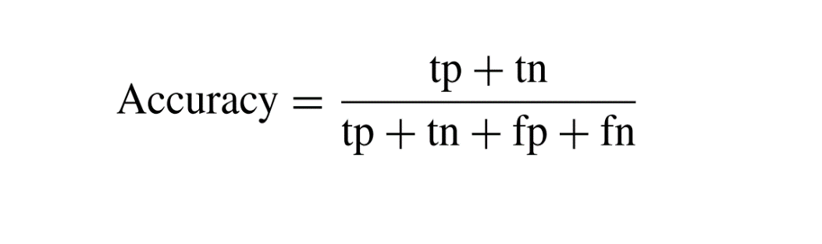

1. **PRECISION**: Also known as positive predictive value, precision measures the proportion of true positive predictions out of all positive predictions made by the model. It quantifies the model's ability to avoid false positives.

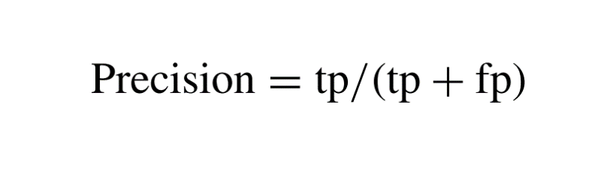

3.**RECALL (SENSITIVITY)**: Also known as true positive rate, recall measures the proportion of true positive predictions out of all actual positive cases in the dataset. It quantifies the model's ability to detect all positive cases.

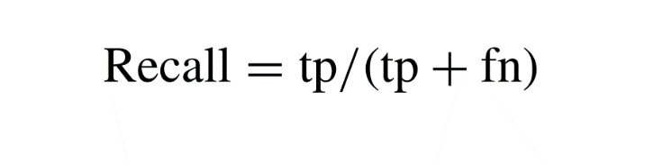

4. **SPECIFICITY**: Also known as true negative rate, specificity measures the proportion of true negative predictions out of all actual negative cases in the dataset. It quantifies the model's ability to avoid false alarms.

5. **F1 SCORE**: The harmonic mean of precision and recall, the F1 score provides a balance between precision and recall. It is useful when there is an imbalance between the number of positive and negative cases in the dataset.

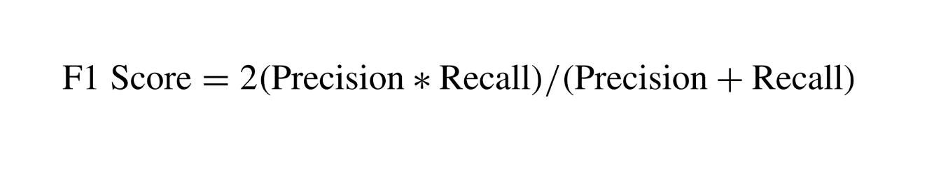

6. **RECEIVER OPERATING CHARACTERISTIC (ROC) CURVE**: A graphical plot that illustrates the trade-off between true positive rate (sensitivity) and false positive rate (1-specificity) across different threshold values. The area under the ROC curve (AUC-ROC) quantifies the model's discriminative ability, with higher values indicating better performance.

7. **CONFUSION MATRIX**: A table that summarizes the model's predictions compared to the actual labels, showing counts of true positives, true negatives, false positives, and false negatives. It provides insights into the types of errors made by the model.

**COMPARISON OF PERFORMANCE OF MODELS**

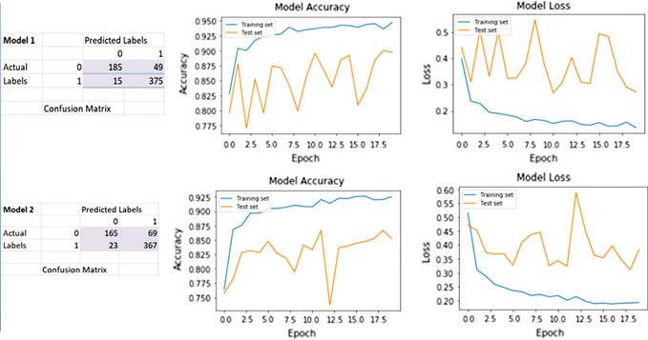

**Fig. 1** Performance of classifier model 1 and model 2

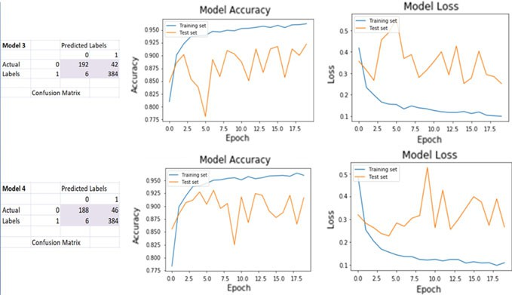

**Fig. 2** Performance of classifier model 3 and model 4

|  |  |  |  |  |
| --- | --- | --- | --- | --- |
| Classifier model | Validation accuracy (%) | Validation loss (%) | Recall (%) | F1 score (%) |
| Model 1 (one conv.layer) | 89.74 | 27.31 | 96 | 92 |
| Model2  (two  Conv.  .Layers) | 85.26 | 38.36 | 94 | 89 |
| Model 3 (three conv.layers) | 92.31 | 25.23 | 98 | 94 |
| Model 4 (4 conv.layers) | 91.67 | 26.61 | 98 | 94 |

**Table 1** PERFORMANCE COMPARISON OF DIFFERENT CNN MODELS

**MODULE VII: DEPLOYMENT AND INTEGRATION**

1. **MODEL SERIALIZATION**: After training, save the trained model in a serialized format, such as HDF5 or TensorFlow's SavedModel format, to preserve its architecture, weights, and configuration. Serialization enables easy deployment and reuse of the trained model without needing to retrain it from scratch.

2. **API DEVELOPMENT**: Develop an API endpoint that can receive chest X-ray images as input, preprocess them if necessary, pass them through the trained model for prediction, and return the predicted results. Use frameworks like Flask or FastAPI to build a robust and scalable API that can handle concurrent requests efficiently.

3.**USER INTERFACE**: Design a user-friendly interface for users to interact with the model. This interface could be a web application, mobile app, or desktop application, depending on the target users and deployment platform. Ensure the interface provides clear instructions for uploading images and displays the prediction results in an understandable format.

4. **DEPLOYMENT**: Choose a suitable deployment platform for hosting the model and API. Options include cloud services like AWS, Google Cloud, or Azure, or deploying on a local server. Consider factors such as scalability, cost, security, and ease of maintenance when selecting the deployment platform.

5. **INTEGRATION**: Integrate the trained model and API into the chosen deployment platform. This may involve setting up server infrastructure, configuring networking and security settings, and deploying the API codebase. Ensure seamless integration between the model, API, and user interface components.

6**. TESTING**: Conduct thorough testing of the deployed system to ensure it works as expected under various conditions. Test the API endpoints with different types of input data, including edge cases and boundary scenarios. Perform integration testing to verify the interaction between different components of the system.

7. **MONITORING**: Implement monitoring tools to track the performance of the deployed system in real-time. Monitor key metrics such as latency, throughput, error rates, and resource utilization to identify and address any issues promptly. Set up alerts and notifications to notify stakeholders of any anomalies or failures in the system. Regularly review and update monitoring configurations to maintain system reliability and performance.

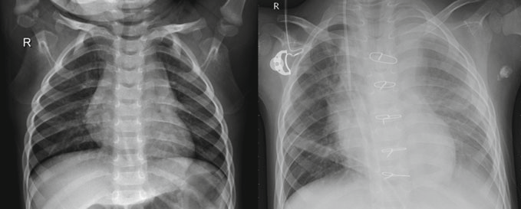

**Fig. 3** Left image depicts normal lungs and right image depicts pneumonic lungs

THE SAMPLE IMAGES FROM THE DATASET USED DURING THE RESEARCH.

**RESULT AND DISCUSSION:**

Six models were trained and tested on Chest X-Ray Images (Pneumonia) dataset consisting of 5216 images for training and 624 images for testing the models. The same technique of data pre-processing has been used for all six models. Performance measures used to analyze and identify the best performing models are Accuracy, Recall, and F1. The main significance of selecting an appropriate performance measure for classification task is an important challenge. In this paper, we have considered

**CONCLUSION:**

This research paper presents two high performing neural networks for real-time applications. Both models are highly accurate and consistent. The recall is an important performance evaluator in this work as it is necessary to minimize the number of false negatives in the case of medical imaging. Recall of Model 2 is as high as 98%, and VGG19 also attains a high recall of 95%. Model 2 and VGG19 networks obtained high f1 scores of 94% and 91% respectively**.**

**FUTURE WORKS**

Future advancements in pneumonia detection using deep learning should focus on several key areas to enhance performance and applicability. This includes exploring multi-modal fusion techniques to integrate data from diverse imaging modalities, such as X-rays and CT scans, for improved diagnostic accuracy. Transfer learning methods can leverage pre-trained models on large datasets and adapt them to medical images' specific characteristics, particularly when labeled data is limited. It's also essential to develop uncertainty estimation techniques and improve model interpretability for greater trust and reliability in diagnosis. Ensuring robustness to variations in image quality, patient demographics, and disease presentation is vital for real-world deployment. Additionally, seamless integration into clinical workflows and large-scale validation studies across diverse patient populations and clinical settings are necessary. Collaboration between researchers, healthcare institutions, and industry partners is crucial to advancing the field and developing clinically useful diagnostic tools for pneumonia and other respiratory diseases.

**REFERENCES:**

1. DARNELL KIKOO , BRYAN TAMIN, Using Various Convolutional Neural Network to Detect Pneumonia from Chest X-Ray Images,(2023).
2. HAO REN , ASLAN B. WONG , WANMIN LIAN, Interpretable Pneumonia Detection by Combining Deep Learning and Explainable Models With Multisource Data,(2021)
3. ROHIT KUNDU, RITACHETA DAS, Pneumonia detection in chest X-ray images using an ensemble of deep learning models,(2021)
4. S. HOSSAIN, RAFEED RAHMAN, Pneumonia Detection by Analyzing Xray Images Using MobileNET ResNET Architecture and Long Short Term Memory(2020).
5. SAEED S. ALAHMARI , BADERALDEEN ALTAZI, JISOO HWANG, A Comprehensive Review of Deep Learning-Based Methods for COVID-19 Detection Using Chest X-Ray Images, (2022)
6. ANSH SAXENA, SHIVA SINGH TOMAR, Deep learning based Diagnosis of diseases using Image Classification(2021)
7. V. SIRISH KAUSHIK, ANAND NAYYAR, GAURAV KATARIA, RACHNA JAIN, Pneumonia Detection Using Convolutional Neural Networks (CNNs). (2020)
8. SHAOLIANG PENG, XIONGJUN ZHAO, Multi-View Weighted Feature Fusion Using CNN for Pneumonia Detection on Chest X-Rays(2021)
9. YAOMING LAI, GUANGMING LI, Pneumonia on CT: A Feasibility Study of Few-Shot Learning for Computerized Diagnosis of Emergency Diseases,(2020)
10. MOHAMMAD YASELIANI 1 , ALI ZEINAL HAMADANI1 , ABTIN IJADI MAGHSOODI, Pneumonia Detection Proposing a Hybrid Deep Convolutional Neural Network Based on Two Parallel Visual Geometry Group Architectures and Machine Learning Classifiers.